

Name : Sarala Devi Muniandy

Login ID : R03412923@oasis-portal.com

Course title : Executive Diploma in Business and Hospitality Management

Subject Code : BHM04 Tourism and Hospitality

Submitted date: **11 September 2017**

**Table of Contents**

|  |  |  |
| --- | --- | --- |
| **No** | **Details** | **Page** |
| 1 | Executive Summary | 2 |
| 2 | Introduction | 3 |
| 3 | Assignment Question |  |
|  | Part 1 | 4,5 |
|  | Part 2 | 6,7 |
|  | Part 3 | 8,9,10 |
|  | Part 4 | 11,12 |
| 4 | Conclusion | 13 |
| 5 | References | 14 |

**Executive Summary**

In this assignment, I am going to discuss about Tourism and Hospitality and also to describe what the Tourism and Hospitality with relevant examples such as hotels, food service, casinos and tourism itself. The Hospitality industry is very diverse and global, today hospitality sector is one of the fastest growing sector in the world and also I would like to clearly explain the definition of Tourism is travel for recreational or business purpose And also about the difference between lodging and type of hotel accommodation in the hospitality industry.lodge are made to provide short duration accommodation to travelers and tourist, hotel are more in number and outscore lodges in grandeur and features.While both a lodge as well a hotel provides accommodation to those who pay for it,a hotel typically also provides meals, whereas there is no provision of food in a lodge.for the last question I have learn the important of entertainment for this industry.

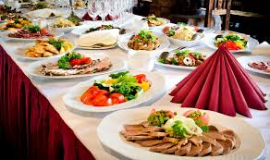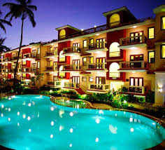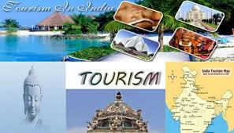

**Introduction**

What is tourism?Travel is defined as a journey from one place to another which is planned and aims to see the place or to enjoy and be done by tourists either individually or collectively. In addition, a range of adventure-based activities can be done by tourists or visitors at a tourist attraction.The tourism industry is one of the sources that contributes to the country. The increase in national income through the tourism industry can improve the living standards of the local communities and the equitable distribution of the economy.The importance of the tourism industry are Increase the economy of a country, Increased cash flow movement, Exchange of foreign currency, Increased government revenue in the form of taxes and Offers job opportunities that can improve the living standards of locals.

What is hospitality? Hospitality is the friendly and generous reception and entertainment of guests. Hospitality indeed both friendly and generous in how you welcome and host your guests. This is simply the action that we do towards others no matter if they are family and friends or strangers. This actions are what we do from the heart and sincere without asking for anything is return. For example serving customer with patient.

What is tourism and hospitality industry? The tourism and hospitality industry is one of the growing segments of the economy. The expansion and growth of tourism products has created vast career opportunities, aiming at meeting the needs of customers at high quality and high quality. Those who work and engage in this industry should always be competent; not only in technical skills but also in interpersonal skills.

**Assignment Questions**

**Q1: Define the Tourism and Hospitality. Explain your understanding about Hospitality industry.**

What is Tourism? Tourism has a variety of purposes according to the perspectives and views of the parties, The parties involved either directly or indirectly with the industry Tourism. These include tourists themselves, accommodation organizations and Transportation, educational organizations, government agencies and so on. There are different type of tourism such as leisure, culture, sport, educational, and so on.

Traveling is a planning and movement activity by a company or organization in relation to all the rules, regulations, and responsibilities and tasks of his or her partner.

For Hospitality, this is simply the action that we do towards others no matter if they are family / friends or strangers. This actions are what we do from the heart and sincere without asking for anything is return. For example serving customer with patient.

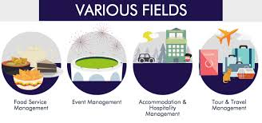

**Explain understanding about hospitality industry**

The hospitality industry is a business industry that provides services to its customers, such as food and beverage service, accommodation, leisure and recreational facilities, tourism services.there are 5 different sector of the hospitality industry:

**Lodging-accommodation**

When people travel from one place to the other, they need a place to sleep. A shelter which will kept them safe from the atrocities of nature. This results in people booking lodges and rooms for their stay. There will be provide with all the services such as food and beverage, room service and more.

**Food and beverage**

Food and beverage sector reign supreme in the industry. And, for good reasons. Such is the popularity and growth of food service establishments that industry pundits are considering full service restaurants as a separate of hospitality industry. People are always look forward to food when they are on the go. When in the different country, people like to taste local cuisines. Its also can let tourists to known the taste of food in the different country.

**Travel and tourism**

Travel and tourism industry is a vast sector of the hospitality industry with several key players across the globe. Most of them include trains, airlines, cruise ships, and several crew members in their service. On the whole, players in travel and tourism segment are in the business of moving people from one destination to another. When we talk about travel and tourism, it is not confined to leisure and travel for fun. Both formal and informal traveling include this division. People travel across the globe businesses, education, entertainment, holidays and many other things.

**Entertainment industry**

If your traveling experience lacks fun and entertainment then you might not be able to enjoy your time up to the fullest. So, for the successful running of a hospitality business, it is important to have in kitty as many entertainment activities as possible. Some of the activities which can elevate your experience when it comes to entertainment. Example visiting a place which relevant with fun and enjoyment such as gaming, dance, and so on.

**Q2: Brief on different type of Tourism categories.**

I going to brief about different type of tourism categories.the different type of tourism is Traveling is one effective way to see the world, experience new cultures and meet new people at the same time. For many tourists, however, traveling accomplishes many other purposes that don’t even have anything to do with the joy of visiting a new place.

**Examples type of tourism are:**

1. **Religious tourism** is another type of tourism where people go to a religious location or locations to follow the footsteps of their founder or to attend a religious ceremony.
2. **Medical or health tourism** is a relatively new type of tourist activity where the main focus of the travel is improving one’s health, physical appearance or fitness. People normally go for another because of their health purposes. And also going for treatment.
3. **Adventure tourism** is another type of tourism that is catered for those who want to do more than just visit regular tourist sites. These kinds of trips involve challenging activities like rock climbing, mountain climbing and wild water rafting.
4. **Family tourism** is another type of tourism that is involve family unit and their participation in diverse forms of tourism.this include visiting ones relatives and friends for interpersonal reason.while visiting friends or relatives, people also visit tourists attractions in and around the city. In this purposes, they also having a great time with their family by traveling to different places.
5. **Sports tourism is Sports tourism** refers to travel which involves either observing or participating in a **sporting** event staying apart from their usual environment. **Sport tourism** is a fast-growing sector of the global travel industry. Its also can let tourists to have fresh air and good health.
6. **Cultural tourism** is the subset of **tourism** concerned with a traveler's engagement with a country or region's **culture**, specifically the lifestyle of the people in those geographical areas, the history of those people, their art, architecture, religions.
7. **Business tourism** is a more limited and focused subset of regular **tourism**. During **business tourism** traveling, individuals are still working and being paid, but are doing so away from both their workplace and home. Some definitions of **tourism** tend to exclude business travel.

**Define Tourism**

Tourism is a business that focus on giving services that offers pleasure and leisure to people going on holiday and at the same time the industry that provides employment opportunity. Tourism is mainly associated with trans national level,but may also refer to travel to another location within the same country. Its also a activities that going to seeing sight view.

The jobs would include as follows:

- **Travel agents**

A **travel agency** is a private retailer or public service that provides **travel** and tourism related services to the public on behalf of suppliers such as activities, airlines, car rentals, cruise lines, hotels, railways, **travel insurance**, and package tours.

- **Hotels and Resorts**

The **resort hotel** is a luxury facility that is intended primarily for vacationers and is usually located near special attractions, such as beaches and seashores, scenic or historic areas, ski parks, or spas. Though some **resorts** operate on a seasonal basis, the majority now try to operate all year-round.

**Q3. Describe the lodging accommodation and types of hotel and accommodation.**

Lodging Accommodation is broad sector service in hospitality and tourism industry example ranging bed,food and breakfast.customer service is providing lodging and accommodation services.

The types of hotel accommodation are as follows:

**Motels**

-Motels are Originally designed for motorists, motels are roadside hotels equipped with minimal amenities and ample parking areas for motor vehicles. There also providing light food to the guests.

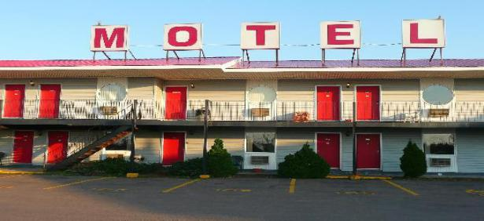

**Hotels**

-An establishment that provides travelers with paid accommodation and other guest services. Depending on size, location, and amenities, **hotel** are generally rated from one-star to five stars. There also providing free meals.

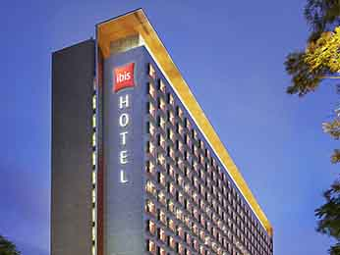

**Hostels**

-Ideal for budget travelers and backpackers, a [hostel](http://www.luxuryaccommodationsblog.com/tagged/hostels" \t "http://www.luxuryaccommodationsblog.com/post/114961446726/_blank) is an inexpensive type of accommodation, usually with shared bedrooms and communal facilities. Its is normally for students.

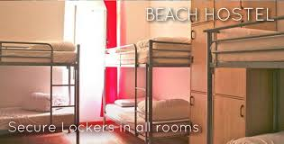

**lodge**

-Although the word ’[lodge](http://www.luxuryaccommodationsblog.com/tagged/lodges" \t "http://www.luxuryaccommodationsblog.com/post/114961446726/_blank)’ has many different meanings, one of them refers to a small rural house used by people on holiday. Its for a temporary enjoyment for people to stay for a short period.



**Resort**

-**Resort** is primarily known as a destination frequented by vacationers in search of relaxation and entertainment, the term is also used to describe a full service lodging establishment that offers extensive guest services and recreational facilities.

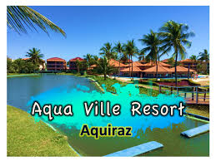

**Guesthouse**

**-**A guesthouse is a private house offering inexpensive accommodation to tourists. Its a house which provide all facilities to guests that their needed. Example such as kitchen, bedroom and so on.

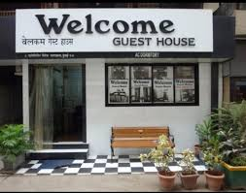

**Q4. Explain the significance of entertainment in this industry.**

Entertainment industry provides the important things in hospitality to the buyers and recipients of all hospitality service.so,this sector of hospitality thrives for us and to Entertainment is a significant part of our travel these days.

It is important because have the kitty as many entertainment activities as possible to run the business successfully.

**The type of entertainment are:**

**Marinas:** Marinas the most popular place to go partying.you can play games,you can dance and enjoy the best of your life. Its can let us to fresh our mind by its entertainment.

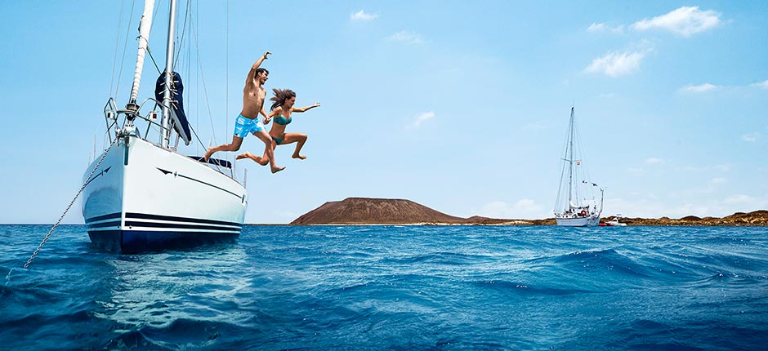

**Cruise:** now days people like to spend their days on luxury ships which sail across the blue oceans under the clear sky. Its will be a great time to the guests by its gaming and fun.

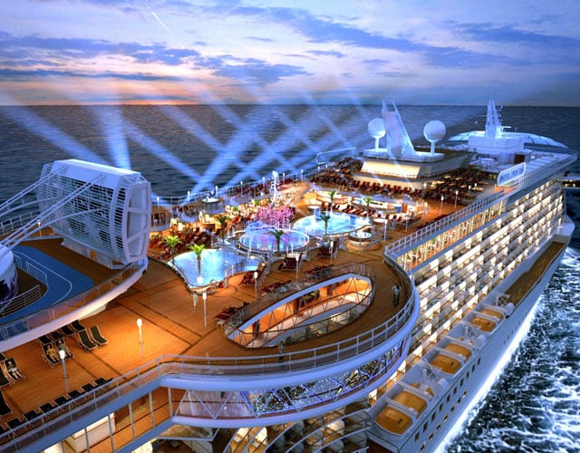

**Sports and gaming:**sports and gaming is a basic things which people are looking for on their travel such as casinos and swimming pool. Its can let guests to have their time with fun.

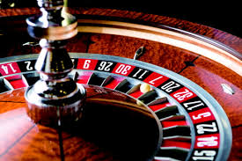

**Nightclubs:**Nightclubs is an entertainment [venue](https://en.wikipedia.org/wiki/Music_venue" \o "Music venue) and [bar](https://en.wikipedia.org/wiki/Bar_(establishment)" \o "Bar (establishment)) which serves alcoholic beverages that usually operates late in the night. A nightclub is generally distinguished from regular [bars](https://en.wikipedia.org/wiki/Bar_(establishment)" \o "Bar (establishment)), [pubs](https://en.wikipedia.org/wiki/Public_house" \o "Public house) or [taverns](https://en.wikipedia.org/wiki/Tavern" \o "Tavern) by the inclusion of a stage for live music. Its also will have a stage dance so that the people can have enjoyment.



**Bars:**Bars is the place which can sitting around table and having a couple of drinks with friends is always a refreshing experience. this is why bars makes an important sector of the hospitality industry because its a entertainment place to people refresh their mind.

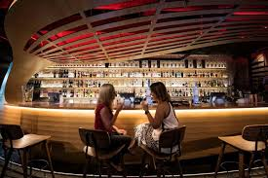

**Conclusion**

For my conclusion, I have learn about the tourism and hospitality and different type of Tourism categories and different type of accommodation. Then, I have learn about the sector of hospitality industry. Besides that, I also can list up the lodging accommodation and hotels accommodation in detail. Lastly, I also can get know about the entertainment industry and its significant. And also the location of entertainment industry.

**References**

Unknown Author, Unknown Date, Online source <https://www.google.com.sg/search?q=tourism+and+hospitality+summary&oq=tourism+and+hospitality+summary&aqs=chrome..69i57j69i61j0.14822j0j4&sourceid=chrome&ie=UTF-8>

Unknown Author, Unknown Date, Online source, Different between lodge and hotel,<https://www.google.com.sg/search?q=define+the+tourism+and+hospitality&oq=define+the+tourism+and+hospitality&aqs=chrome..69i57.38388j0j8&sourceid=chrome&ie=UTF-8>

Unknown Author, Unknown Date, Online source, Definition tourism, <http://www.tugberkugurlu.com/archive/definintion-of-tourism-unwto-definition-of-tourism-what-is-tourism>